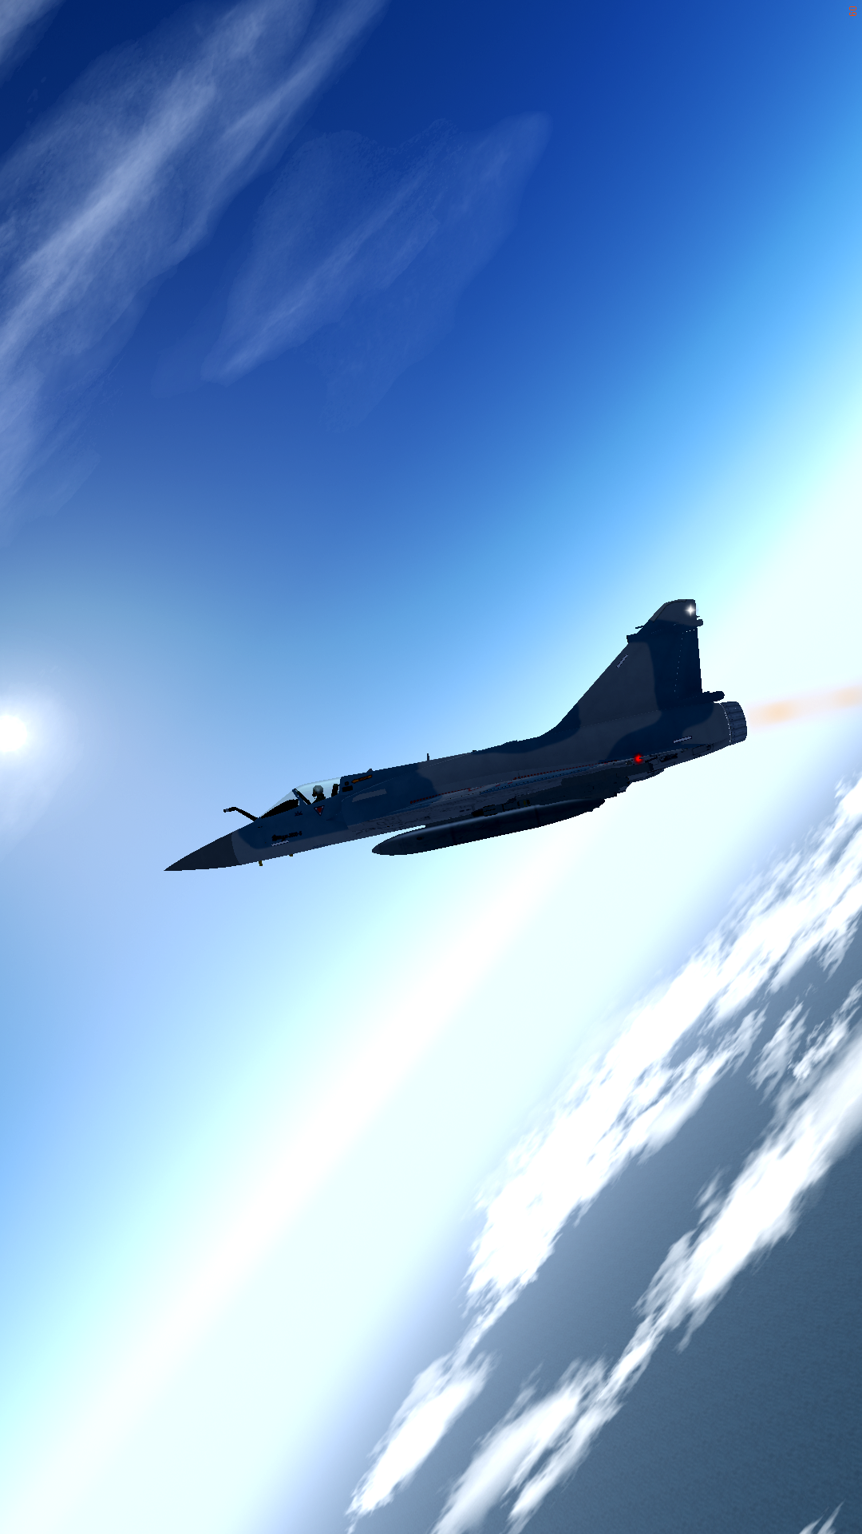

Dassault Mirage 2000-5 Flight Manual
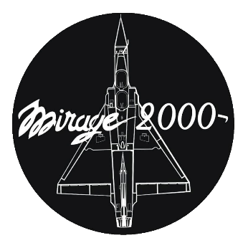

Introduction

The Mirage 2000 is a multirole all-weather fighter aircraft from Dassault Aviation. It is one of the best dogfighters and a fair beyond visual range combat aircraft, as well as very capable in air-to-ground strikes. This manual has been written in order to help you get to know the Mirage 2000 and master flying and fighting with it. The French Delta Knife is not always easy to handle, but I hope this short book will allow you to become better at fighting with it.
Enjoy your flight!

-Capt. Wolf

Table of contents

History 7
Data sheets and information 9
Generalities: 10
Aircraft data: 10
Flight data: 11
Weapons and payload: 12
External pylons loads: 12
Super 530D: 13
R550 Magic II: 13
MICA-IR: 14
MICA-EM: 14
GBU-12 Paveway II: 14
SCALP-EG: 14
AS-30 Lazer: 15
AS37 Martel: 15
AM39 Exocet: 15
ASMP-A: 15
Guns: 16
Engine: 17
Radar: 18
Radar warning system: 19
Fuel system: 20
Controls 21
Miscellaneous: 21
Radar: 21
Weapons / payload: 21
Countermeasures: 22
Instruments 23
Checklists 26
Start-up: 26
Pre-flight: 27
Ground targeting with the PDCLT: 28
A/S strike: 28
A/G stand-off strike: 29
Before air-to combat: 29
Flying 30
Start-up: 30
Taxi: 30
Take-off: 30
Initial climb: 31
Climb: 32
Interception procedures: 32
Intercepting a high aircraft: 33
Cruise: 34
Low altitude flying (terrain following): 34
Refuelling: 35
Autopilot: 36
Visual landing: 37
Information Landing System landing: 37
Locating with TACAN: 38
Navigation 39
Visual Flight Rules (VFR): 39
Map display (right MFD): 39
Map display (down MFD): 39
Air-to-air combat 40
Generalities: 40
Beyond visual range combat: 40
Before the fight: choose your armament: 40
Before the fight: choose your external tanks: 41
Before the fight: identifying your enemies: 42
Within visual range combat: 42
Basics: 42
Dogfight: 43
Cockpit instruments 44
Figure 0.1: Cockpit panel 44
Figure 1.1: Heads-Up Display 45
Figure 2.1: Radar 46
Figure 3.1: Left panel 47
Figure 3.2: Left panel 48
Figure 4.1: Right panel 49
Figure 4.2: Right panel 50
Figure 5.1: Top left panel 51
Figure 6.1: Top right panel 52
Figure 7.1: Left and right multifunction displays 53
Figure 7.2: Right MFD: EHSI (electronic horizontal situation indicator) 54
Figure 7.3: Right MFD: RMU (Radio management Unit) 54
Figure 7.4: Right MFD: RWR (Radar Warning Receiver) 55
Figure 7.5: Right MFD: EICAS (Engine Indicating and Crew Alerting System) 55
Figure 7.6: Right MFD: moving map 56
Figure 7.7: Left MFD: EADI (electronic attitude direction indicator) 56
Figure 7.8: Left MFD: Loads dialog 57
Figure 8.1: Centre multifunction display 58
Figure 8.2: Interactive map 59
Figure 8.3: Interactive map 59
Figure 8.4: Plan 60
Figure 8.5: VOR/APP 60
Figure 8.6: VOR/APP 61
Figure 9.1: Transponder 62
Last words... 63
Acknowledgements 64

History

In 1972, the ACF (“Avion de Combat Futur”, future fighter aircraft) program intended for air superiority was launched: the aircraft must have a fixed wing, two M53 engines, and replace the Mirage F1 and Mirage III. This overly ambitious program was stopped on December 12, 1975 and the unfinished prototype was scrapped. However, the Delta 2000, a single-engine fighter, designed on Marcel Dassault’s own funds, interests of the Air Force. Smaller and cheaper than the ACF, likely to compete with the F-16, it was chosen on December 18, 1975, and quickly renamed Mirage 2000.
The Mirage 2000 therefore returns to the famous delta formula, but includes fly-by-wire, a first for a European aircraft. Its wing is equipped with variable camber and has only been made possible by new technologies.
Naturally unstable, the airplane turns out to be very manoeuvrable, because the centre of gravity merges with the centre of the airplane. In addition, its equivalent radar surface is reduced. Although with a similar shape to the Mirage III or 5, it is an entirely new aircraft. Its cell is built mainly in aluminium, but also contains titanium and carbon fibres.
The aircraft was ordered with 4 prototypes in 1976. They will be powered by M53-2s of 7500 kgs of thrust, while the production version will be propelled by M53-5s of 9000 kgs of thrust.
The Mirage 2000 “01” flew for the first time on March 10, 1978, in the hands of Jean Coureau, in Istres. It is followed by the “02”, which flew on September 18, 1978, the “03” which flew on April 26, 1979, and the “04”, which flew on May 12, 1980. The Mirage 2000 made its first public appearance at Farnborough that same year and landed immediately competing with the F-16. There, it achieved 204 km/h with 26 degrees of incidence. 400 flight hours were completed before the prototypes were sent to flight testing centre of the Armée de l’Air.
The production Mirage 2000C flew for the first time on November 20, 1982, and entered service with the 2nd fighter squadron in Dijon in 1984, on the occasion of the fiftieth anniversary of the Air Force. However, the M53-P2 engine and RDI radar suffered from laborious tuning. This is why it entered service in an underpowered version, equipped with an M53-5 engine, and, for the first 37 examples, with RDM radar. The final 2000C RDI version entered service in 1987: as its name suggests, it is equipped with the RDI radar as well as the M53-P2 reactor with 9700 kgs of thrust. Although the aircraft is primarily intended for air superiority, it has good air-to-ground attack capabilities.
Dassault upgraded the Mirage 2000 to the -5 standard by giving it in particular the radar of the Mirage 2000-9, the RDY-2. This is more discreet and is a synthetic aperture radar, with visualization of moving targets. It also has the FLIR targeting pod, the MDPU (Modular Data Processing Unit) of the Rafale, the Thales Totem 3000 inertial navigation system coupled with a GPS and the ICMS electronic countermeasures system.

Text by Clansman, from https://avionsmilitaires.net

Data sheets and information
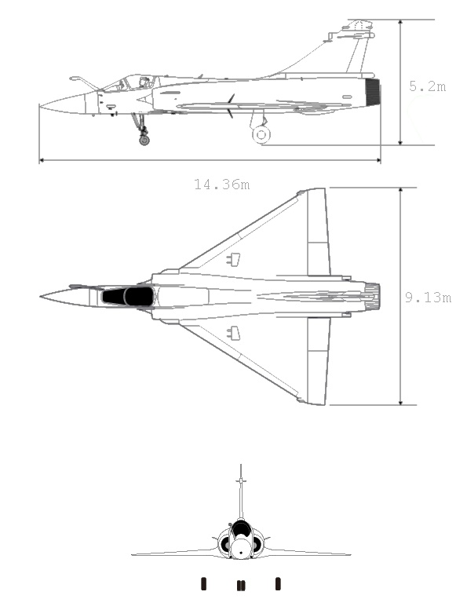

Generalities:
The Mirage 2000 first flew on 10. March,1978.
It was designed to be a high-flying, bi-sonic interceptor, mainly to protect the country from the omnipresent threat of Soviet bombers. The Mirage 2000-5 Mk.2 (the current version in FlightGear) is one of the latest versions of the Delta Knife, in service in the French Armée de l’Air in several squadrons, and is mainly used as an interceptor and as a bombing platform.
While the Mirage 2000 looks similar to the old Mirage III, it is far different, and better on almost all aspects. It has a better engine, which allows it to attain bi-sonic speeds without a dry thrust rocket, it is more manoeuvrable, has FBW, better avionics and armament.
Compared to other modern fighters such as the F-16 and F/A-18, the Mirage 2000 is a very good fighter, and a formidable opponent in dogfights.

Aircraft data:
Crew: 1
Length: 14.36m
Wingspan: 9.13m
Height: 5.2m
Wing area: 41m²
Propulsion: 1 turbofan engine “SNECMA N53-P2”
Empty weight: 7,500kg
Internal loads: 2 internal 30mm cannons “DEFA 554”
External loads: 9 pylons (3 heavy)
Wheelbase: 5m
Axle track: 3.6m

Flight data:
Maximal in-flight time: 150 minutes
Maximal Mach at sea level: 1.2
Maximal Mach at 36,000ft: 2.2
Action radius with air-to-air loadout: 830nm
Action radius with air superiority loadout: 780nm
Action radius with air-to-ground loadout: 640nm
Maximal in-flight time: 150 minutes
Minimal take-off distance: 1,650ft
Operational ceiling: 60,000ft
Maximal altitude: 80,000ft
Maximal climb rate: 60,000ft
Instantaneous turn rate at Mach 0.7: 22°/second
Instantaneous turn rate at Mach 0.9: 17.5°/second
Instantaneous turn rate at Mach 1.2: 13°/second
Instantaneous turn rate at Mach 1.5: 10.5°/second
Stabilized turn rate at Mach 0.7: 11.5°/second
Stabilized turn rate at Mack 0.9: 11°/second
Maximal operational G-load: 9G
Maximal structural G-load: 13.5G
Internal fuel capacity: 3,950L
External fuel capacity (supersonic): 4700L
External fuel capacity (subsonic): 5700L
Maximal take-off weight: 16,500kg

Weapons and payload:

External pylons loads:
Centre: pylon.C
Under fuselage forward left: pylon1.L
Under fuselage forward right: pylonB.R
Under fuselage rear left: pylonB.L
Under fuselage rear right: pylon2.R
Inner left wing: pylon3.L
Inner right wing: pylon3.R
External left wing: pylon2.L
External right wing: pylon2.R
 | 2.R | 3.R | B.R | 1.R | C | 1.L | B.L | 3.L | 2.L
S530D |  | X |  |  |  |  |  | X
R550 | X |  |  |  |  |  |  |  | X
MICA-IR | X |  |  |  |  |  |  |  | X
MICA-EM |  |  | X | X |  | X | X
GBU-12 |  |  |  |  | XX
SCALP-EG |  |  |  |  | X
AS30L |  | X |  |  |  |  |  | X
AS37M |  | X |  |  |  |  |  | X
AM39 |  | X |  |  |  |  |  | X
ASMP-A |  |  |  |  | X
1300L droptank |  |  |  |  | X
1700L droptank |  | X |  |  |  |  |  | X
2200L droptank |  | X |  |  |  |  |  | X

Weapons data:
 | Super 530D | Magic II | MICA-IR | MICA-EM
Type | Fox 1 | Fox 2 | Fox 2 | Fox 3
Range | 21.6nm | 0.3 - 8nm | 32 – 43nm | 32 – 43nm
Weight | 270kg | 89kg | 112kg | 112kg
Cruise alt | 80,000ft | 36,000ft | 36,000ft | 36,000ft
Speed | Mach 5 | Mach 2.7 | Mach 4 | Mach 4

 | GBU-12 | SCALP-EG | AS30L | AS37M
Type | LGB | AGM | LG AGM | A/R AGM
Range | <6.5nm | 300nm | <6.5nm | 80nm
Warhead | 200kg | 450kg | 240kg | 120kg
Weight | 496kg | 1,300kg | 520kg | 535kg
Speed | - | Mach 0.8 | Mach 1.3 | Mach 0.9

 | AM39 Exocet | ASMP-A
Type | ASM | Nuclear missile
Range | 70nm | -
Warhead | 165kg | -
Weight | 870kg | 840kg
Speed | Mach 0.9 | -
Cruise alt | 6ft | -

Super 530D:
FOX-1 medium range missile. It is necessary to guide it to its target. It accelerates very fast and is the Mirage’s fastest missile. Very useful at close-medium range.

R550 Magic II:
FOX-2 short range missile. Can shoot targets with very high angles of aspect, but not at very high G-loads. It is a “shoot-and-forget” missile which corrects trajectory every tenth of a second, and it is quite deadly. To shoot it, paint your opponent with radar and lock on them to shoot the missile. It accelerates very fast and is comparable to the AIM-9. If engaged in a dogfight, shoot it when you are close to your opponent, to get more chances of killing them before they can release flares.

MICA-IR:
FOX-2 medium range missile. Far better performance than the Magic II, due to its thrust vectoring engine. It can also go much faster, and can be shot at medium range as well. Fire-and-forget as well, it is the second-to-best infrared missile in the market. However, it is forbidden to use it in OPRF due to this extreme performance.

MICA-EM:
FOX-3 medium range missile. Shoot-and-forget, it is very precise due to its thrust vectoring, and is better than the S530D over medium ranges. It can also be shot at close range, but the S530D and the FOX-2s are preferable in this case. If against one opponent only, you can simultaneously shoot an EM and IR so you have more chances of getting a splash on your enemy. Even if the Mirage can take 4 MICA-EMs, do not waste them, as your opponent will most certainly kill you if you don’t have ammunition left.

GBU-12 Paveway II:
500kg-class laser-guided bomb unit based on the Mark 82 bomb. Can be shot with the help of the targeting pod's camera or with the “Follow closest GD AI/MP" option. The HUD will show you when the best shooting position is (as close to zero as possible).

SCALP-EG:
Air-to-ground long-range subsonic standoff cruise missile. Can be used over very long range and is very precise.

AS-30 Lazer:
Air-to-ground laser-guided short-range missile. Can be shot with the help of the targeting pod's camera or with the “Follow closest GD AI/MP" option.

AS37 Martel:
Anti-radiation air-to-ground missile. Can be used over long ranges.

AM39 Exocet:
Air-to-sea medium-long-range subsonic missile. It is one of the most dangerous air-to-sea missiles (see Falklands war and USS Stark incident). It is advised to stay under radar sight of the targeted ship to keep from being shot at yourself, and shoot the Exocet above water only, otherwise it might hit the ground before reaching the sea because of its very low cruise altitude.

ASMP-A:
Nuclear supersonic standoff cruise missile. This missile cannot be shot in FlightGear and never will be.

Guns:
The Mirage 2000 is equipped with two 30mm revolver cannons at the wing root, on the lower side. Each one of them has a magazine of 125 armour-piercing rounds of 30mm by 113. To fire the guns, set master arm to on, select guns and press the trigger. If the trigger is pressed for half a second, a burst of 5 bullets from each magazine will be shot, 10 from each if it is pressed for an entire second. If it is pressed continuously after this, the rounds will be shot according to the selected rate of fire. To change it, go in the options menu and select the rate of fire with the “A/A => A/G => Lower...” slider.
Rates of fire:
Air-to-air | 1,800 rounds/min
Air-to-ground | 1,100 rounds/min
Lower... | <1,000 rounds/min

The gunsight is an indicator which helps you aim (it tells you where your bullets will hit in real time). It is attached to the gun snake (direction in which the bullets will go) which itself is attached to the aiming cross in the middle of the HUD. The gunsight is shown by two horizontal bars above 1 nautical mile, and like this when you are in shooting range (below 1 nautical mile): 
A circle will appear around the gunsight if you are closer than 1nm, and it will slowly disappear as you get closer.
1 nautical mile | 
700 meters | 
350 meters | 
<300 meters

Engine:
The Mirage 2000 is equipped with a single SNECMA N53-P2 turbofan with afterburners. Its thrust with full military power is at 64.3kN, and with full afterburner power at 95.1kN. When on ground at idle (throttle lever fully back), the engine should be running at 47% RPM. When idling in air, the engine should be running at 56% RPM. Military power is between 0% and 85% of the stick’s longitudinal position and afterburners are between 85% and 100% of the stick’s longitudinal position. To engage afterburner, it is necessary to lift the stick above the stopper. If afterburner is engaged, there should be double angle brackets, and if it is not there should be single brackets.
Throttle stick positions:
0% (throttle fully back) | 47% RPM / 56% RPM
0% - 85% | 47% RPM – 100% RPM
85% (throttle to stopper) | 100% RPM
85% - 100% (throttle lifted above stopper and forward) | 101% RPM / 102% RPM
100% (throttle fully forward) | 102.5% RPM

Characteristics:
Air flow rate | 94kg/s
A/B specific fuel consumption | 2.1 kg/daN.h
Dry engine thrust specific fuel consumption | 0.9 kg/daN.h
Pressure ratio | 9.8
Bypass ratio | 0.36

Radar:
{see the radar}
The Mirage 2000 is equipped with the RDY-2 doppler radar, which can track up to 24 targets, and 8 simultaneously in active seeking. It can track targets up to 160nm away in FlightGear and can follow terrain. However, it cannot detect ground targets. It has a look-down, shoot-down capacity, and can detect an F-16 with transponder and radar off at 66 nautical miles without active seeking mode.
To show an aircraft’s distance, you can use the dashes on the right side of the radar screen to give you an approximate distance, and to know their exact location you can set your radar to active seeking and select them as target. You can also know their flight level and direction by looking at the number next to their position on the radar screen and the small dash going out of the position. When using Link16 with your wingmen, you cannot lock on them, so your radar will cycle the unknown targets only.
Properties:
 | Active seeking off | Active seeking on
Search cone | 120° | 30°
Search angle | 3.5° | 3.5°
Scan speed | 50°/s | 100°/s
Search angle (horizontal) | 60° | 12°

Bugs: the radar can sometimes mistake a callsign for another, it is thus a good idea to check your wingmen's position from time to time and confirm the targets' positions with them.

Radar warning system:
{See the RWR}
The radar warning system shows received signals only (other aircraft with transponder or painting you). It shows the relative position of other aircraft towards your aircraft. There are two positions in your RWR: within engaging range (inside the large circle) or beyond engaging range (outside the large circle). The smaller circle represents the aircraft, and the little cross in its middle means the RWR is working correctly. Its range is the same as the radar’s, and if an aircraft is beyond the selected range, its relative position might be false. The lines on the sides of the RWR show the approximate “clock” angles to the detected aircraft. When the RWR detects a missile launch, you will hear “Incoming” + angle, and the aircraft having launched the missile will be shown with a circle around it.
RWR symbols:
A-10 Thunderbolt II | 10
F-14 Tomcat | 14
F-15 Eagle | 15
F-16 Falcon | 16
MiG-21 Fishbed | 21
SU-27 Flanker | 27
MiG-29 Fulcrum | 29
JA-37 Viggen | 37
SR-71 Blackbird | 71
Jaguar | JA
Mirage 2000 | M2
EF-2000 Typhoon | EF
BUK-M2 | 11
Other aircraft types might show, but these are not armed in FlightGear, so they do not represent any threat.
Bugs: the RWR can sometimes show the same aircraft as before if another pilot respawned with a different aircraft but the same callsign. As with the radar, check other pilots’ positions regularly.

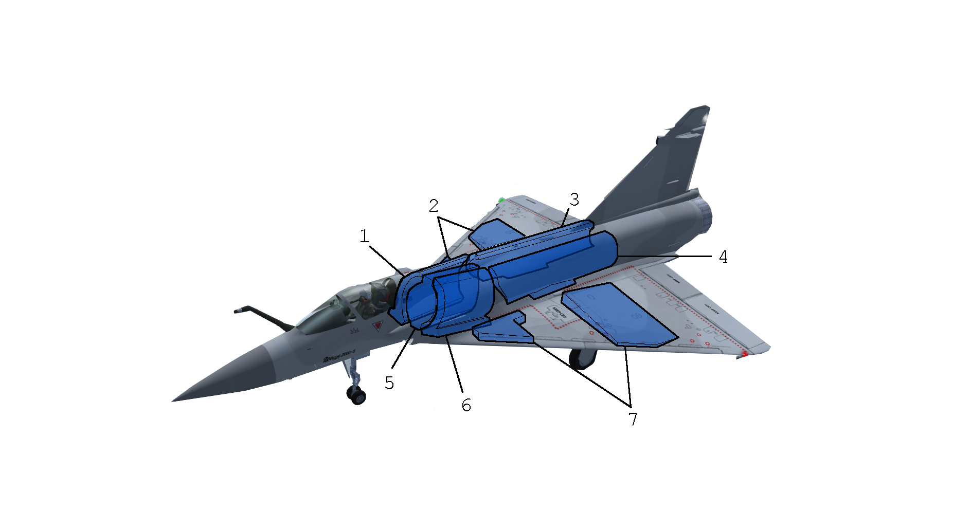
Fuel system:
 | Description | Kg. | Lb. | Gal. | L.
1 | Right forward | 304 | 670 | 101.7 | 385
2 | Right wing | 523 | 1154 | 175 | 662.5
3 | Right feeder | 592 | 1306 | 198.1 | 750
4 | Left feeder | 592 | 1306 | 198.1 | 750
5 | Centre | 320 | 705 | 107 | 405
6 | Left forward | 304 | 670 | 101.7 | 385
7 | Left wing | 523 | 1154 | 175 | 662.5
 | Total internal | 3160 | 6966 | 1056.6 | 4000
 | Centre external | 990 | 2182.6 | 343.4 | 1300
 | Right external supersonic | 1580 | 3482.3 | 528.6 | 1700
 | Left external supersonic | 1580 | 3482.3 | 528.6 | 1700
 | Total supersonic | 7310 | 16111.2 | 2457.2 | 8660
 | Centre external | 990 | 2182.6 | 343.4 | 1300
 | Right external sub-sonic | 1738 | 3831.6 | 581.2 | 2200
 | Left external sub-sonic | 1738 | 3831.6 | 581.2 | 2200
 | Total subsonic | 7626 | 16811.8 | 2562.4 | 9660

Controls

Miscellaneous:
D Toggle canopy
} Engine start-up
ctrl + E x 3 Eject
B Apply ground / air brakes
ctrl + B Apply air brakes
K Open air brakes
J Close air brakes
shift + E Open / jettison drag parachute

Radar:
Q Radar standby toggle
shift + R Radar active seeking toggle
T Increase radar distance
shift + T Decrease radar distance
N Next target by range
ctrl + N Previous target by range

Weapons / payload:
M Master arm toggle
W Weapon type cycle
E Fire selected weapon
shift + J Jettison external fuel tanks
F6 Toggle automatic FLIR tracking

Countermeasures:
L Launch chaffs / flares
shift + Q Toggle ECM (Not working)

Instruments

Figure 1: Attitude indicator
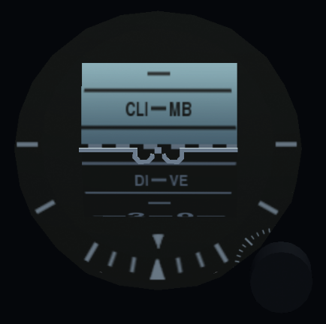
The ball shows the turn angle, pitch angle and the ball. The pitch is shown by the blue/black cylinder and each line is worth 5 degrees (blue for sky=>nose up; black for ground=>nose down). The ball is shown below.

Figure 2: Airspeed indicator
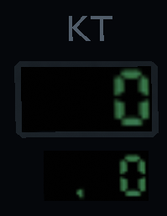
The airspeed indicator shows the speed in knots (above) and in Mach (below).

Figure 3: Angle of attack indicator
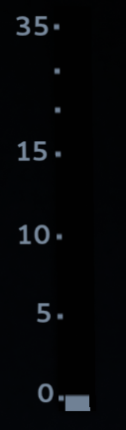
The AoA indicator shows the angle formed between the longitudinal axis of the aircraft and the relative wind direction with -2 < AoA < 35. It will make a shrill sound when at high AoA levels. It is recommended not to go above 26 AoA because you will stall. In a dogfight, your aircraft’s AoA will bob from 11 to 22. This is normal, as the

Figure 4: Heading indicator
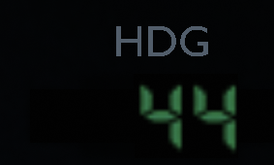
The heading indicator will show you your true heading in degrees.

Figure 5: Climb rate indicator
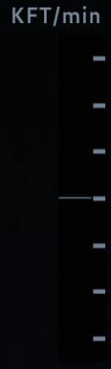
The climb rate indicator will show you your climb rate in thousands of feet per minute with - 4,000ft < climb rate < + 4,000ft. One bar is equal to 1,000 feet, and the middle bar is equal to a stabilized horizontal path with climb=0ft/min.

Figure 6: Altitude above sea level indicator
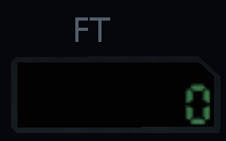
The ASL indicator shows you your altitude in feet. Depending on your location on the world, the ASL altitude will not necessarily be the same as the real sea level, so be sure to check radar altitude in your HUD as well.
Clock
The clock will show you the local time.
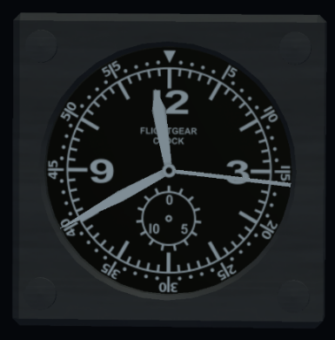
Gear indicator
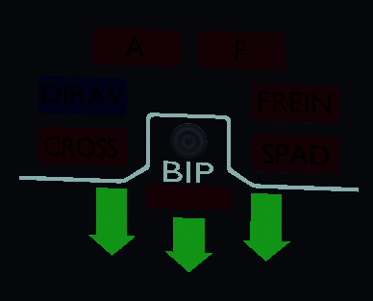
The gear indicator shows the gear position (three green arrows=gear down, red rectangle under “BIP” =gear up or in motion). Above the indicator, you can see the pedal brake indicator (the “FREIN” beacon will light up when you are braking) and the airbrake indicator (the “A” and “F” beacons will light up when the airbrakes are extended or in motion).

Airbrakes/slats indicator
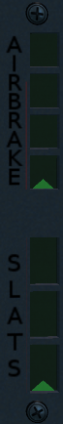
The airbrake indicator shows the position of the airbrake: retracted (as shown in picture), opened 25% (one rectangle filled), opened 50% (two rectangles filled) and so on.
It is the same case with the slat indicator, but these are automatic, so you do not need to pay much attention to them, only at high AoA you can check if they work to give you additional lift.

Checklists

Start-up:
{For the following checklist, see the right panel}
- Check fuel
- Switch the battery on
- Turn on both alternators
- Turn on the transformator
- Switch the cut-off and secure it
- Switch the left and right (G and D) pumps to “M”
- Switch the “VENT ON”
- Open the protection of the starter
- Check that the BP button has been switched
- Press the starter during 1 second
- Press the fuel P button
- Wait about 30 seconds for the fuel pumps to reach the correct level
- Open the guard and switch the start selector to ON, the engines will spool up
- Deselect the Fuel P
The engines are now idle, you can go on to the next part of the tutorial.

Pre-flight:
For the following checklist, see the right panel and the right MFD}
- Close the canopy
- Turn on A/C and set it to 16.9 – 18°C by turning the knob (WARNING: F=froid=cold and C=chaud=hot)
- If you are about to fly at high altitudes, it is advised to enable the anti-fog feature in the air conditioning panel
- Select flight mode to “TO” from the flight mode menu
- Set transponder according to your mission
- Set the right MFD according to your mission (compass; radio; RWR; engine dialog; map)
- Set the navigation dialog according to your mission
- Reload flares and guns (fully loaded by default)
- Toggle multiplayer shot report if you intend to fight. Otherwise, you can leave it off, as it can be enabled in air in case you need it, and if someone decides to attack you with no reason you cannot be shot down.
- Remove automatic missile view if you intend to fight
- Select payload according to your mission:
PO | 2x R550, 1x 1300L tank | Law enforcement (“sky police”)
Fox old years | 2x R550, 2x S530D, 1x 1300L tank | Old air superiority payload
Fox | 2x R550, 4x MICA-EM, 1x 1300L tank | Newer air superiority payload
Fox full MICA | 2x MICA-IR, 4x MICA-EM, 1x 1300L tank | Newest air superiority payload
Bravo | 2x R550, 4x MICA-EM, 2x 2200L tank | Long-range A/A mission
Kilo | 2x MICA-EM, 4x MICA-EM, 2x 1700L tank, 1x 1300L tank | Long-range supersonic A/A mission
Air-to-ground | 2x R550, 2x GBU-12, 1x PDCLT | Bomb strike
Anti-radar | 2x R550, 2x AS37M, 1x 1300L tank | Wild weasel
Air-to-sea | 2x R550, 2x AM39, 1x 1300L tank | Anti-ship
M2000N | Nuclear strike load | Nuclear strike

Ground targeting with the PDCLT:
- Activate sniping view
- Go to sniping view (infrared)
- Use F6 to activate the FLIR tracking
- Click on your target to select it
- Select “sniping mode”
The lat/long data should fill itself automatically, you can then select which weapon you will use.

A/S strike:
{For the following checklist, see the radar}
- Master arm on
- Select AM-39 Exocet
- Radar active seeking
- Select the ship you want with radar
- Once above the sea, fire your missile

A/G stand-off strike:
{For the following checklist, see the radar}
- Open the [ ground targeting ] dialog from the [ configuration ] menu
- Enter your target’s coordinates in the lat/long input
- Acquisition
- Master arm on
- Select a long-range missile (SCALP-EG, AS37M)
- Radar active seeking
- Select the ground target created in your radar
- When in range, fire your missile

Before air-to combat:
{For the following checklist, see the radar and the RWR}
- Set link16 accordingly if you have wingmen
- Set the right MFD to RWR
- Radar active set at the correct distance
- MICA-EM selected for BVR, guns for WVR
- FOV 100-120°, looking up a bit so that you keep eye contact with your opponent in dogfight, but keep sight of your RWR
- Turn the pilot cam view slightly up and decrease FOV so you have a wide angle

Flying

Start-up:
When your aircraft is cold and dark before start-up, the external generator and fuel truck are connected to your aircraft, and protections (in red) will be on your aircraft, as well as chocks. They will disappear automatically as you start up. With the [ } ] key, you can auto-start your aircraft.
{To start up the engine manually, see the Start-up checklist}

Taxi:
The Mirage can taxi at relatively high speeds, usually below 40kts, but you shouldn’t go faster than 20kts when turning. Even if the track width is larger than usual, you should always stay at safe speeds.
The front gear can turn 90° to the left and to the right, so a turn radius of 3 meters is reachable, but you should add thrust, as it is difficult to move with the front gear almost entirely turned. Do not push on the rudder pedals too much when braking, otherwise the aircraft may fall on one side or another if you turn too tight.
The taxi lights have an angle of about 30 degrees in front of the aircraft and are not attached to the moving part of the front gear, so they will always light in front.

Take-off:
Line up on the best runway for the current weather conditions and ask for clearance. Once the clearance is given and after releasing the parking brake, spool up while keeping the pedal brakes enabled. Then, throttle up to 99%RPM (military power) for long runways, 100%+ (with afterburners) for short runways or with heavy loadout. Rotate speed is at 120 knots when with clean loadout, 140 knots if with payload. After this, bring the inverted “T” in the HUD under the line of horizon and you should be able to lift off at 170-190 knots, depending on your loadout. Do not exceed 14° nose angle or you will tail-strike.
The Mirage needs long runway distances to take off, as it hasn’t got a separate horizontal tail stabilizer/elevator. Because of the elevons’ position (trailing edge of the wing), they create a considerable loss of lift when they are moved up to rotate, so higher rotation speeds are needed. Also, the delta wing is often called “flying airbrake”, as they generate lots of drag at high angles of attack, like at take-off. This is why high speeds and long runways are needed.

Initial climb:
After taking off, retract the landing gear before reaching 280kts (maximum gear extension speed). You are advised to follow the runway heading until you are at an acceptable speed (approximatively 200 knots), but if you used reheat and you are not heavy, you can turn as soon as you are at 200 knots. However, you have to watch your speed so you don’t stall, at this altitude, a stall doesn’t forgive. After having chosen the correct heading and having attained 250 knots, you can commence your climb with full military power, at the beginning around 2,000 feet per minute to gain speed, and when you have reached your optimal climb speed you may pull the nose up to climb at a rate of 4,000 feet per minute. Remember that if you are faster, you will have an lower angle of attack and will thus drag less, and your elevons will not need to be pulled fully up (and thus will not create too much additional loss of lift), so it is advised to speed up before climbing too fast.

Climb:
The Mirage can climb exceedingly fast, with a maximum climb rate of 60,000 feet per minute. With full tanks and PO loadout, it is able to climb with full military power at a rate between 4,000 feet and 6,000 feet without bleeding speed (between 250 and 300 knots). With full afterburners and in the same conditions, the climb rate can go up to 12,000 feet, still in zero/zero conditions. If going vertical with full afterburners and a base speed of 400 knots, you can reach 20,000 feet before having to push the nose back down. This is the fastest way of climbing.

Interception procedures:
Intercepting a slow aircraft (helicopter, GA aircraft):
It is likely that at some point in your career you will have to intercept a slow-flying aircraft such as a helicopter, private aircraft or a military transport plane. In this case, to identify it, first come behind them at about three hundred meters, slightly above. At this distance, you should be able to identify the aircraft.
- If it is a civilian aircraft, you can fly near them with more or less 18 degrees of angle of attack to go to the slowest speed possible, get their identification and communicate with them. If their radio is down, you can signal them to follow you by rocking from side to side and flashing navigation lights, and to land by putting down your gear. To make them turn, you can turn tight in front of them and launch flares, so they see which way they should head. If they are too slow for you, you can go in circles around them, applying reheat to turn tighter and be with them as much as possible to guide them. If it is simply for an identification, you just need to pass one time, note the identification and return to base.
- If it is a military aircraft, you should keep your distance. Once you see what model they are, you can often determine if their intentions are friendly or not. Otherwise, it is advised to come in below, with infrared missile lock, and identify the aircraft type and the roundel. This should give you an idea. If the aircraft is “friendly”, you can redirect it like a civilian aircraft. If it is armed, it is a good idea to call backup in case the interception escalades in an aerial combat, if the current situation can turn out to be like this. If you have a wingman or more, they can position themselves behind the bogey to keep them in missile lock while you give them directions. Remember that at any moment, a supposedly “friendly” aircraft can turn out to be “red”. In case of evasion or aggressive behaviour, do not shoot unless given orders to. You can’t shoot at anyone who tries anything. If they get aggressive and shoot, you are perfectly allowed to defend yourself, hence the need for wingmen.
Note: An aircraft without external weapons can still have a loaded gun.

Intercepting a high aircraft:
Take off with full afterburners and start climbing slowly to 5,000 feet with full military power, then engage afterburners to reach 550 knots. Pull the nose up at 3-5G and go vertical, then let the aircraft’s nose fall slowly to behind you, so as to be almost horizontal when the aircraft reaches 200 knots. Wait until you are near your target’s speed, then disengage afterburners, apply full military power and use your radar to guide you to your target. After this, apply usual interception procedures.

{For more information about Interception procedures, see the FlightGear guide on intercepting aircraft}

Cruise:
The Mirage 2000 normally cruises between angels 35 and angels 40, and this is the best altitude for Mach 2+ flights. It can also go above 50,000 feet, and up to 80,000 feet, but with difficulties. The optimal cruise altitude is 36,000 feet. While it has a bi-sonic flight possibility, it consumes lots of fuel. It is thus advised to stay sub-sonic during cruise flights, without using afterburners. With cargo loadout and without using afterburners, the Mirage can fly for more than two hours. For long cruises, it is advised to use the navigation, altitude and speed autopilots {see the autopilot tutorial}

Low altitude flying (terrain following):
The Mirage 2000 can perform low-altitude terrain following. There are two ways to enable it:
- Engage autopilot and altitude hold. Then, set your desired altitude in the EADI (left MFD). After this, click again on the altitude hold button. The aircraft’s autopilot will now base itself on the AGL altitude instead of the ASL altitude {See the autopilot panel}
- When flying below 1000 feet AGL, double-click on the altitude hold button. The aircraft will hold the current AGL altitude. You can change the desired altitude in the EADI (Left MFD). If you move the stick, the terrain following autopilot will pause.
You can change the smoothness of the movements in the options menu, in “AP TF Smooth (+ -)”.

Refuelling:
The Mirage 2,000 has a perch refuelling capacity, making it able to fly for very long distances and stay airborne much longer (the longest missions from the Armée de l’Air sometimes require to stay on-station for up to ten hours). It also has a buddy-buddy refuelling capacity, but this is not implemented in FlightGear.
- Set your TACAN to the tanker’s {See Locating with TACAN}
- Get close to your tanker’s location: if you have enough fuel, you can use afterburner to reach the tanker if it is higher, but it is not advised. You should never waste fuel, except on emergencies. If possible and if you aren’t in a fight, only use military power.
- Approach your tanker. Come in radio contact with it and let it guide you. You can also use your onboard radar to track it down and get closer.
- Form up with the tanker. Normally, you should come on “perch left” before tanking, which means ten metres behind and to the left of the basket. Try to stay as still as possible.
- Ask for the right quantity of fuel, depending on how much you still have left in your tanks. After this, ask for clearance to make contact with the tanker and refuel.
- When given the clearance to, speed up very slightly (one knot, two maximum) to come in contact with the basket. Make no sudden moves and play with the thrust to stay at the right speed. Your perch should fit in the basket and the fuel will start to flow in your tanks.
- When you have enough fuel, disconnect and come to the right of the basket, ten meters away (“perch right).
Your refuelling is now finished. You can go more to the right to let your wingmen tank as well.

Autopilot:
{For the following tutorial, see the autopilot panel, the EHSI and the EADI }
The autopilot on the Mirage controls the pitch and roll of the aircraft. If you click on the |AP| button, it will stabilize all flight controls to keep the current attitude if -3° < pitch < 3° and -10° < roll < 10°. Otherwise, the autopilot will make your aircraft return to 0° pitch/roll.
If you select |Stby| as well as |AP|, you can still control your aircraft, but when you release the stick, the autopilot will regain control.
If |Vs| is selected, your aircraft will stabilize itself on your current climb rate and not move in roll. It cannot be active when the AP altitude is selected.
If |Alt| is selected, your aircraft will stabilize itself on the altitude set in the EADI and not move in roll, unless terrain following is selected (see previous tutorials).
If |Hdg| is selected, your aircraft will use the roll axis (and not the yaw) to turn to the heading set in the EHSI. It cannot be active when AP navigation is selected.
If |Nav| is selected, your aircraft will follow the radial selected in the EHSI.
If |App| is selected, your aircraft will position itself in the correct path for an ILS approach if your initial approach is relatively correct and will take care of the pitch and roll and the runway you intend to land at will appear highlighted in your HUD.
If |Spd| is selected, your aircraft will regulate the engine thrust automatically to match the speed set in the EADI. It will never engage afterburner and only use military power, you thus cannot go supersonic with autopilot. This feature does not exist in real life.

Visual landing:
Lower the gear when you are below 195 knots, then approach the runway at 175 knots (for 15% fuel left; add 5 knots every 20% additional fuel). {Check fuel in the Fuel indicator} If by night, put the landing lights on. On final approach, hold an angle of attack of between 6 and 9 degrees. {See AoA indicator} When passing the runway threshold, flare and bring the aircraft to an angle of attack of 12 degrees. You should land at 145 knots (for 15% fuel left; add 5 knots every 20% additional fuel). When touching down, wait for the aircraft to slow down to 135 knots and apply pedal brakes, and drag parachute if necessary (heavy loadout or short runway).

Information Landing System landing:
- Look up your selected runway’s ILS frequency (you can see it in the Location > Airport menu: type in the ICAO and you will have all the necessary information on the airfield.
- Set the ILS frequency accordingly in the bottom right panel {See the ILS settings}
- Click on the NAV buttons of the right MFD in the EHSI (the two top left buttons) {See the EHSI}
- Steer approximatively towards the runway (optional) at least 5 nautical miles before (for smooth landing without too many corrections)
- Enable autopilot speed at the according approach speed (see above) {See the autopilot panel}
- Enable “App” autopilot
- Do not touch the stick, let the aircraft steer itself until the runway threshold
- When crossing the runway limits, you can either disable the autopilot to finish the landing manually (e.g. if there is a strong crosswind) or leave the autopilot on until touchdown. In the second case, set the autopilot SPD to touchdown speed and let the aircraft do the rest
- When in contact with the runway, the autopilot will automatically disengage
- Open the drag parachute
- Apply brakes under 135 knots
- When having finished braking, jettison the parachute and vacate the runway

Locating with TACAN:
- Set the TACAN to your tanker (or other platform)’s frequency {See the TACAN settings}
- Double-click on the top left button from the right MFD in the EHSI to enable the TACAN heading bug {See the EHSI}
- Follow the heading given by the TACAN bug in the EHSI

Navigation

Visual Flight Rules (VFR):

Map display (right MFD):
{For this section, see the moving map}
The map in the right MFD is the fourth page in the right multifunction display. It is magnetically oriented and shows your position at the centre of it (small red Mirage) and your orientation. It is in colour and shows you the littorals, major cities, roads and noticeable visual “anchors”. It is not extremely precise due to the small scale of the map, but gives you an idea on where you are. You can use it to navigate visually.

Map display (down MFD):
{for this section, see the interactive map}
The map in the bottom MFD shows the waypoints’, the airports’ and the VOR/DMEs’ relative position to your aircraft, without terrain (simply their positions). You can set a range of 10; 20; 40; 80 or 160 nautical miles. It is oriented to the longitudinal axis of your aircraft and can show your waypoints as well. You can select what you want to show with the upper buttons of the MFD: airports, waypoints’ data, waypoints, position points and weather data. It can come in handy while looking for a near airport or simply following the waypoints you set in your navigation data without autopilot because you are flying low, for example. It also shows you the distance to these points.

Instrumental Flight Rules: see Autopilot, ILS and TACAN.

Air-to-air combat

Generalities:
The Mirage 2000 is a very capable fighter, whether as interceptor, air-to-ground platform or long-range strikes. It is also an outstanding dogfighter and a powerful air-to-sea platform. All in all, it is comparable to fighters such as the F-16 or the MiG-29.
To learn how to use all these advantages, you must first learn everything you need to know about your aircraft, but your opponent’s as well: advantages, weaknesses, limits, particular behaviour in certain conditions... This will help you find the best action to take in combat. Also, it’s good to know in which cases your aircraft is in disadvantage against another aircraft, so you can avoid this kind of situation. The following paragraphs will give you an insight in this, but you should also read the manuals of other aircraft to know what is to be expected from them and which ones of their disadvantages you should exploit.

Beyond visual range combat:
The Mirage 2000 has a wide variety of air-to-air weapons, and can take up to 8 missiles. It can shoot an opponent at more than 40 nautical miles without entering their range of fire and is also a very capable FOX-1 fighter.

Before the fight: choose your armament:
The first thing you should know is that, if possible, take MICAs. Those are the best missiles the Mirage has, and you should not use another missile unless you want an additional pair (the Mirage can take up to 6 MICAs, plus two S530D if needed). However, taking an additional pair of Super 530Ds on a Fox Full MICA payload means not taking outer wing external tanks, and thus taking far less fuel (when taking external tanks, you add 3,400 to 4,400 litres of fuel) and having additional drag. This is not always a very good choice, as you have to guide the missile all the way to its target to register a potential hit, and thus putting yourself at a disadvantage. This is why MICA-EMs are better than S530Ds: they are shoot-and-forget missiles which follow your target with their on-board radar and not yours. Also, if you hesitate between Magic IIs and MICA-IRs, take the latter: they are much more manoeuvrable thanks to their thrust vectoring, and they also have a better seeker. However, due to this, their use is not allowed in OPRF, the FlightGear military community, since they are much more advanced than any other FOX-2 missile, so don’t take them if you are doing an event there.

Before the fight: choose your external tanks:
If you are not going to do an air-to-ground strike, always take a 1300L external tank on the centre pylon, as you cannot store any air-to-air weapon on this pylon and it is always safer to have additional fuel. As for the outer wing tanks: For long-range missions, it is advised to take sub-sonic external tanks, so you can add 1,000 litres to your fuel load and can travel farther. Also, supersonic tanks are useful only when you need to do supersonic flights, otherwise stay sub-sonic and save fuel. If doing a high-speed interception, they might be useful, but if it is a short-range interception, they will do nothing more than drag you down with their weight. In this case, having only the central tank is the best option, as you have additional fuel but not too much weight and it enables you to climb faster.

Before the fight: identifying your enemies:
If you do not have wingmen, then it is easy: any contact is a bogey and it might be a bandit. If you have wingmen or allied forces, be certain to add their callsigns in your Link16 and constantly be aware of their situation and location. Also, trust your AWACS’ radar above yours: as said above, the radar can sometimes mistake a callsign for another. If a bogey locks you up, your RWR will show it as a relatively high menace contact at the appropriate angle, and you can direct yourself to them. If you do not see anyone on radar or RWR, then the targets are probably too far or hidden by relief. In this case, climb to a higher altitude and ask for directions from your AWACS.

Within visual range combat:
The Mirage 2000 is one of the tightest-turning aircraft, with an instantaneous turn rate of 22 degrees. It is powerful and a formidable opponent against most contemporary fighter aircraft. However, it bleeds speed rapidly due to its airframe, and is inferior to other aircraft like the F-16 in terms of stabilized turn rate. In this section, you will learn how to use those characteristics to win a dogfight.

Basics:
The Mirage has a very good turn rate, and you can keep on with full reheat for several minutes in a high-G turn. However, you should always try to save fuel (for example in dives) so you don’t become bingo before the fight is over. If you do become bingo, it is advised to break off, dive and get out of the engagement airspace as fast as possible. Also, the Mirage 2000 tends to bleed speed, as the delta wing is a “flying airbrake”, and the position of the elevons reduce lift when you pull up, so the stabilized turn rate is not excellent. The instantaneous turn rate is far better, so you will use this to your advantage. Finally, the Mirage is extremely manoeuvrable, with a bank rate of 270 degrees per second. This comes in handy when you are behind a slower aircraft and you need to bleed speed not to overshoot. You should know all these characteristics so you can avoid getting in complicated situations and use your aircraft’s performance to its best.

Dogfight:
{See the book “Fighter Combat: Tactics and Manoeuvring” by Robert L. Shaw}

Cockpit instruments

Figure 0.1: Cockpit panel
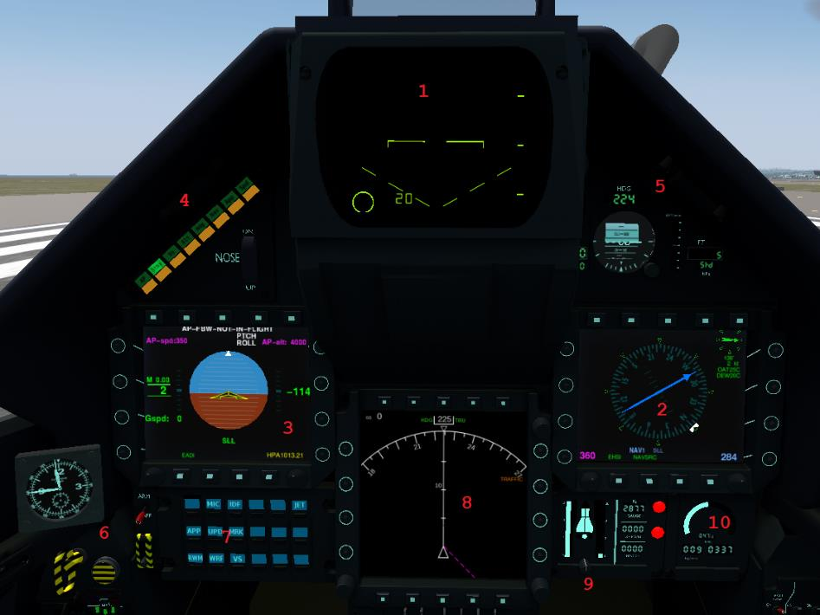
- Radar display
- Right multifunction display
- Left multifunction display
- Autopilot
- “Clocks”
- Armament controls
- Weapons display
- Map
- Fuel gauge
- Engine RPM / fuel flow

Figure 1.1: Heads-Up Display
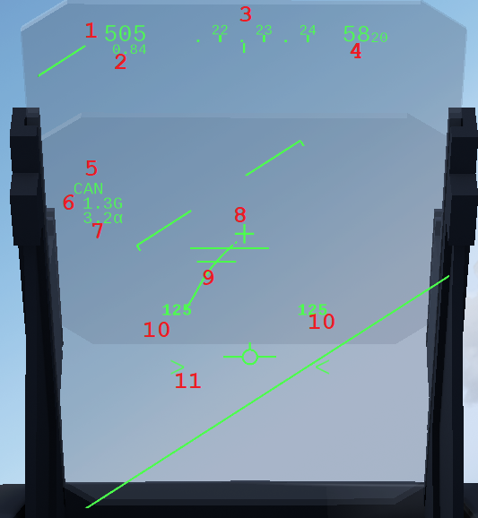
- Airspeed in knots
- Airspeed in Mach (above M 0.7)
- True heading in degrees (x 10)
- Altitude above sea level in feet
- Selected weapon
- G-load
- Angle of attack in degrees
- Gunsight without movement and at close range
- Gun snake + gunsight (three different modes: two lines at long distance, a circle at close range, open circle at very close range)
- Selected pylon / remaining rounds
- Accelerometer (double angle brackets with reheat, single without reheat)

Figure 2.1: Radar
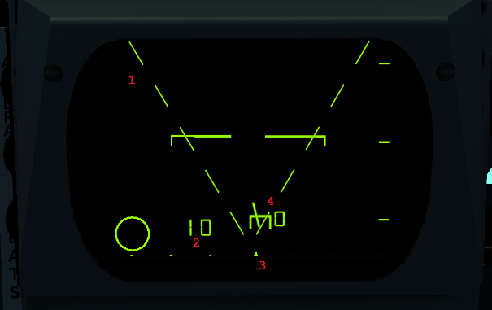
- Radar search area (small angle if active seeking, wide angle if not)
- Radar range in nautical miles (distances: 10; 20; 40; 80; 160)
- Radar focus position
- Radar contact (Gives direction and flight level)

Figure 3.1: Left panel

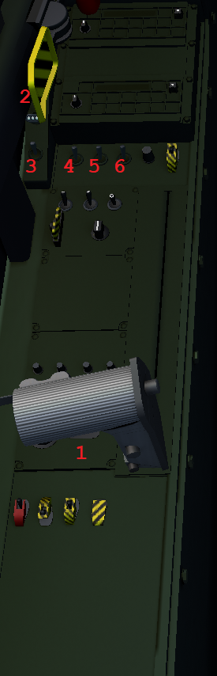
- Throttle handle
- Landing lights
- Dorsal flashlights
- Formation lights
- Tail position light
- Wing position lights

Figure 3.2: Left panel
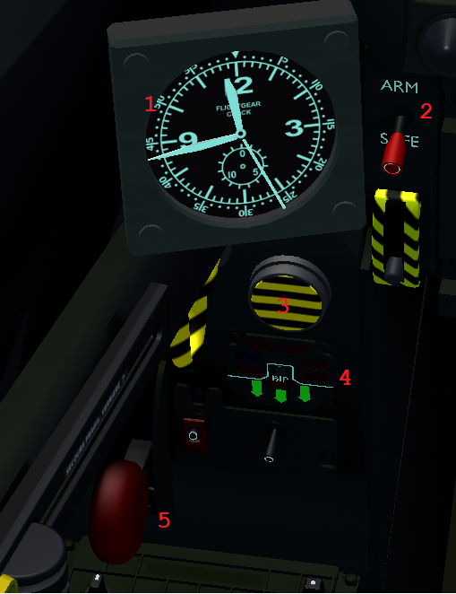
- Clock
- Master arm lever
- Emergency fuel tank jettison button
- Gear indicator
- Gear lever

Figure 4.1: Right panel
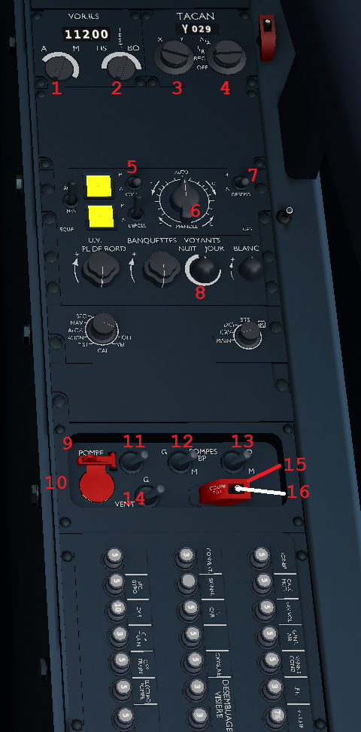
- VOR ILS adjust knob
- VOR ILS adjust knob
- TACAN adjust knob
- TACAN adjust knob
- Air conditioning button (off by default)
- A/C temperature in degrees Celsius (left: hot; right: cold)
- Remove fog on canopy
- Cockpit light adjust knob
- Start button protection
- Start button
- Pump BP button
- Left pump button
- Right pump button
- Select start button
- Cut-off protection
- Cut-off button

Figure 4.2: Right panel
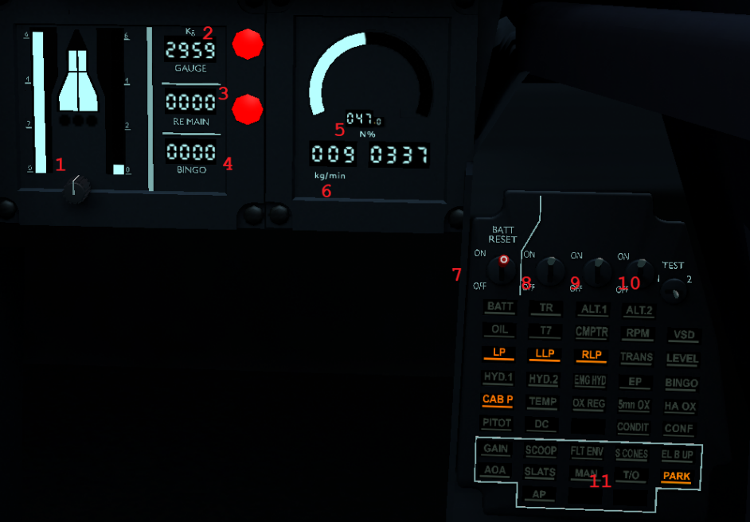
- Remaining fuel gauge
- Remaining total fuel dialog
- Remaining fuel before bingo dialog
- Bingo fuel
- Engine RPM in percentage / Engine RPM in RPM
- Fuel flow in kg/minute
- Battery button
- Alternator button
- Alternator button
- Alternator button
- Alert panel

Figure 5.1: Top left panel
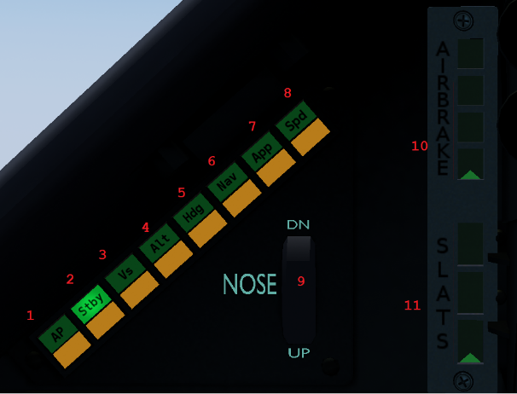
- Autopilot toggle
- Standby toggle
- Current vertical speed hold
- Altitude hold set by autopilot controls
- Heading hold set by autopilot controls
- Follow navigation input
- ILS
- Speed hold set by autopilot controls
- Elevator trim
- Airbrake position indicator
- Slat position indicator

Figure 6.1: Top right panel
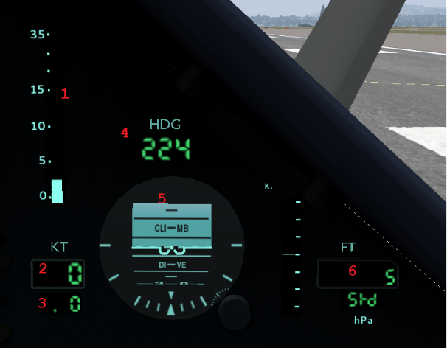
- Angle of attack in degrees
- Airspeed in knots
- Airspeed in Mach
- Heading in degrees
- Ball
- Altitude above sea level in feet

Figure 7.1: Left and right multifunction displays
- Cycle pages (See following figures)
- Change NAV source (blue arrow) [Right MFD: EHSI]
- Show RMI NAV1, TACAN, ADF2 (red arrow) [Right MFD: EHSI]
- COMM + NAV selector [Right MFD: RMU]
- Show RMI NAV2, ADF1 (aiguille jaune) [Right MFD: EHSI]
- swap frequencies Standby <-> Selected COMM + NAV [Right MFD: RMU]
- Set heading bug [Right MFD: EHSI]
- Set radial NAV [Right MFD: EHSI]
- Set altimeter [Left MFD: EADI]
- Set autopilot altitude [Left MFD: EADI]
- Set ADF and TACAN frequencies [Right MFD: RMU]
- Set ADF and TACAN frequencies [Right MFD: RMU]
- Set autopilot speed [Left MFD: EADI]
- Set COMM and NAV frequencies [Right MFD: RMU]
- Set COMM and NAV frequencies [Right MFD: RMU]
- Select canopy
- Set screen luminosity
- Select unit of pressure for altimeter [Left MFD: EADI]
- Swap frequencies Standby <-> Selected ADF + TACAN [Right MFD: RMU]
- ADF + TACAN selector [Right MFD: RMU]

Figure 7.2: Right MFD: EHSI (electronic horizontal situation indicator)
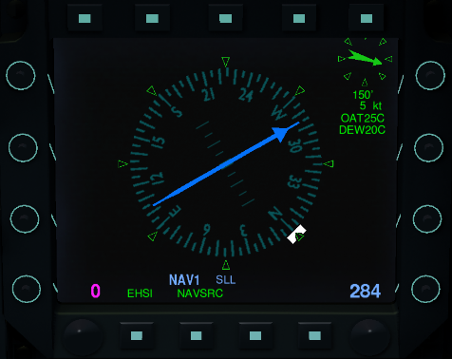

Figure 7.3: Right MFD: RMU (Radio management Unit)
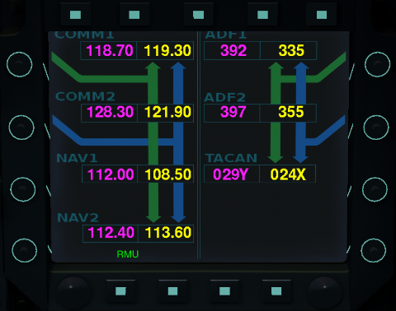

Figure 7.4: Right MFD: RWR (Radar Warning Receiver)
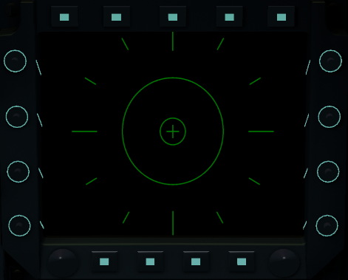

Figure 7.5: Right MFD: EICAS (Engine Indicating and Crew Alerting System)
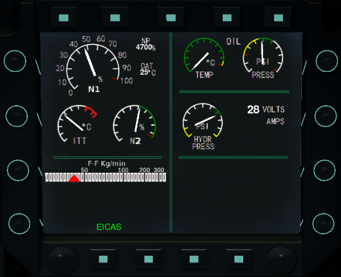

Figure 7.6: Right MFD: moving map
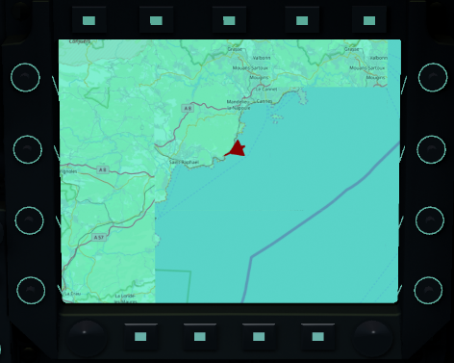

Figure 7.7: Left MFD: EADI (electronic attitude direction indicator)
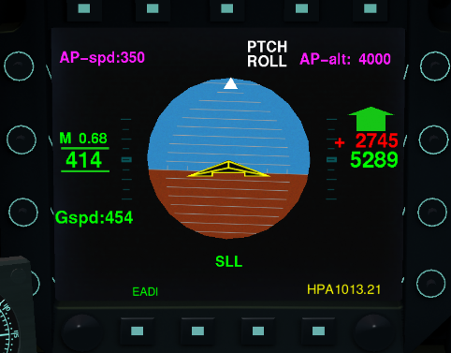

Figure 7.8: Left MFD: Loads dialog
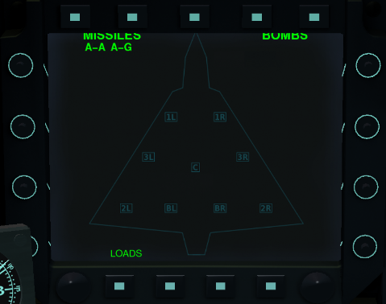

Figure 8.1: Centre multifunction display
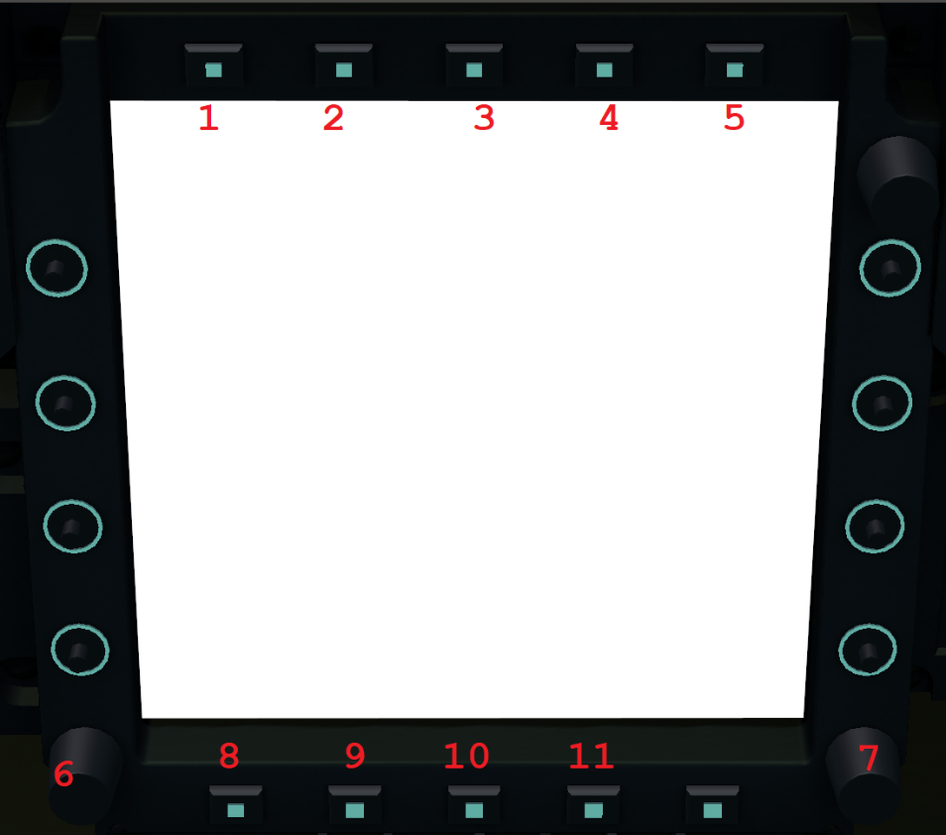
- Show/hide airports
- Show/hide waypoint data
- Show/hide waypoints
- Show/hide position points
- Show/hide weather data
- On/off button
- Set range in nautical miles (distances: 10; 20; 40; 80; 160)
- Cycle pages (see following figures)
- Toggle liquid crystal display/cathode ray tube display
- Toggle centre ND
- Toggle true/magnetic heading

Figure 8.2: Interactive map
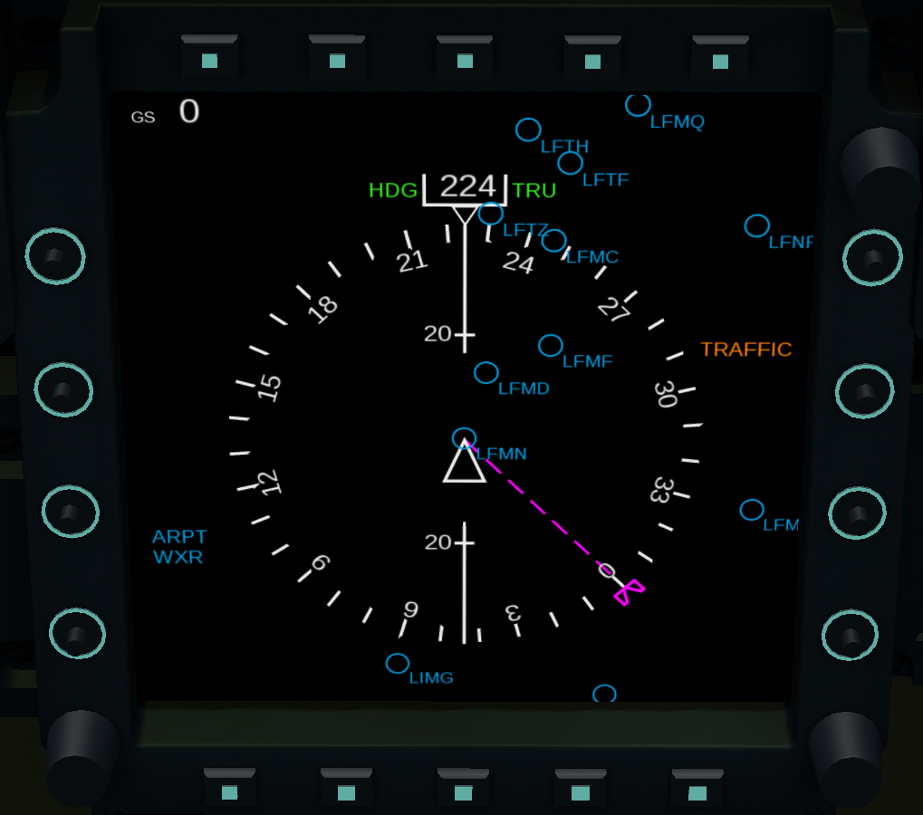

Figure 8.3: Interactive map
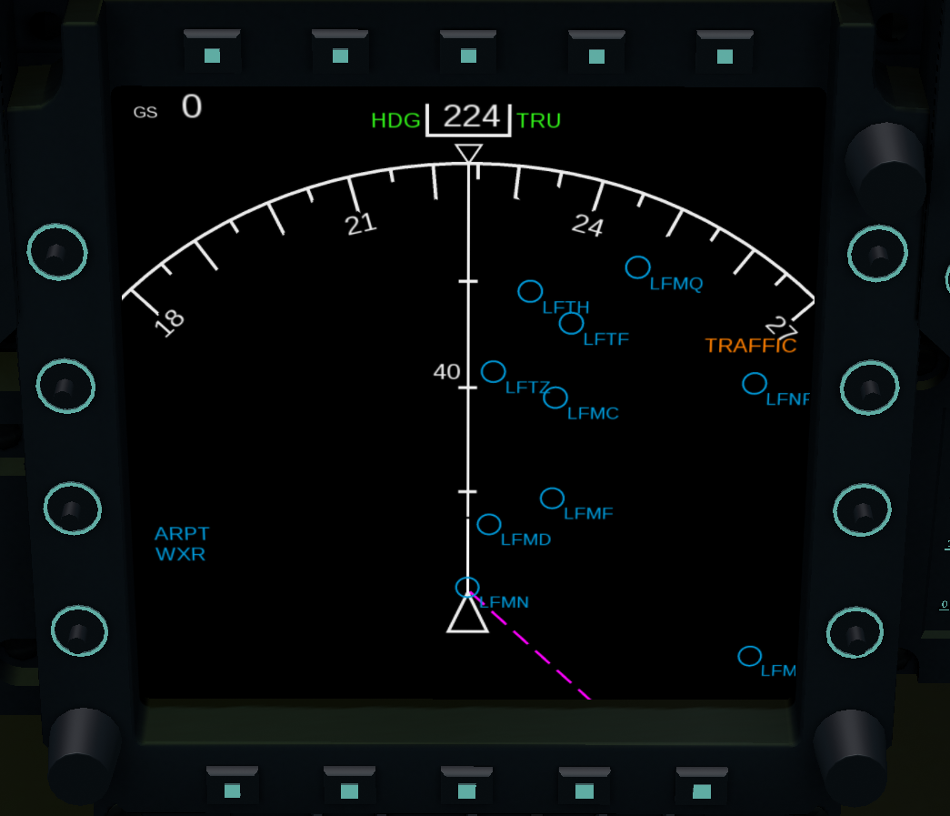

Figure 8.4: Plan
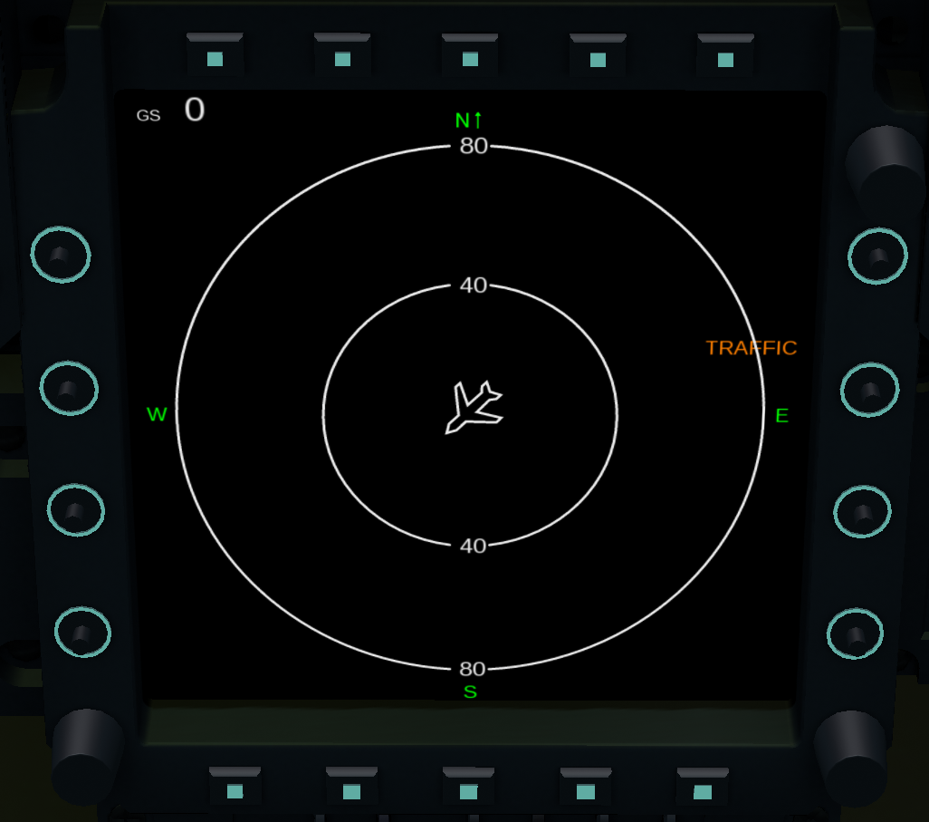

Figure 8.5: VOR/APP
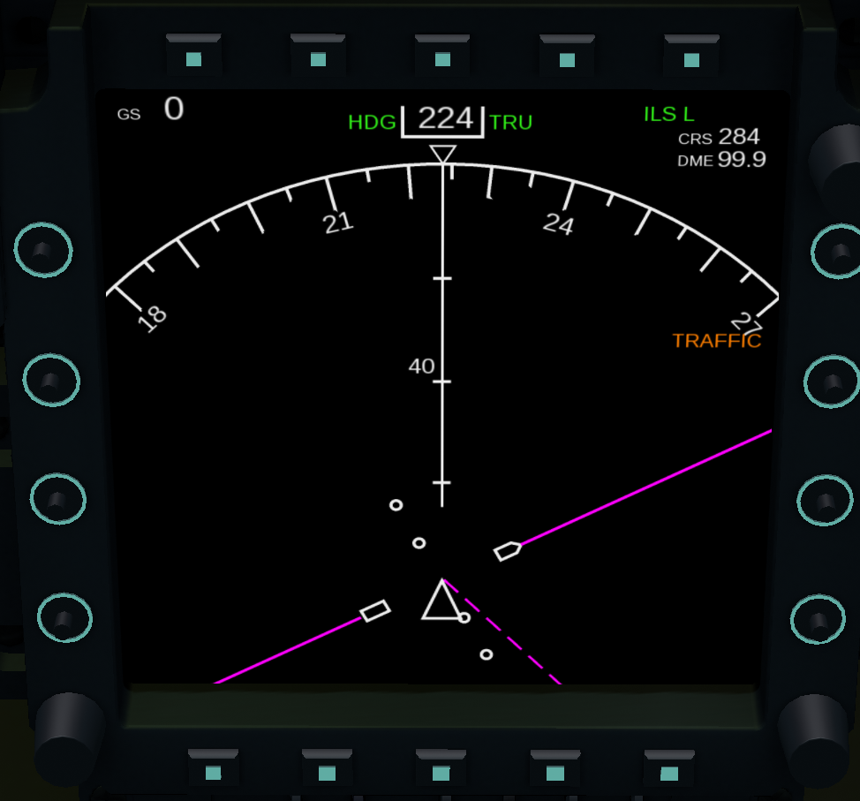

Figure 8.6: VOR/APP
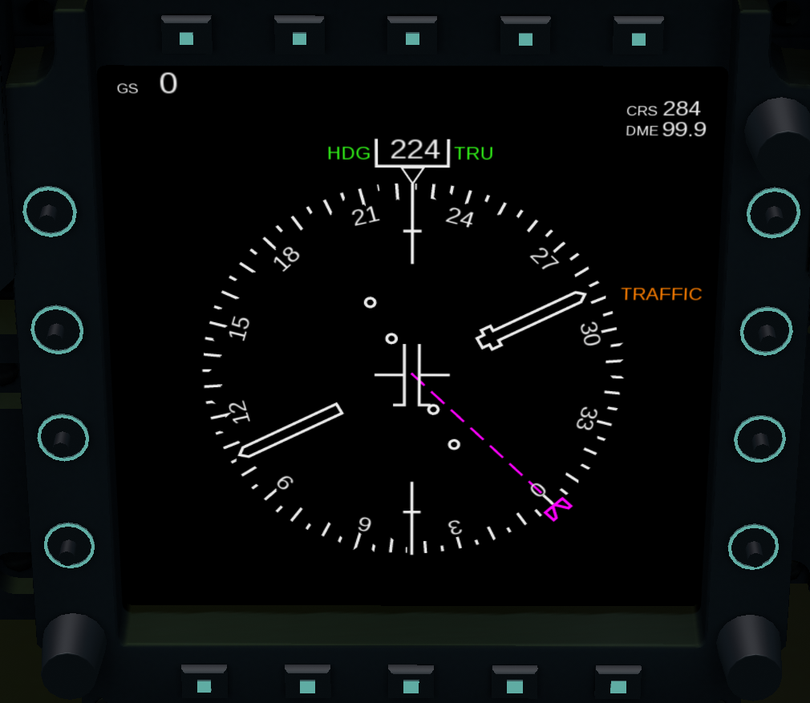

Figure 9.1: Transponder
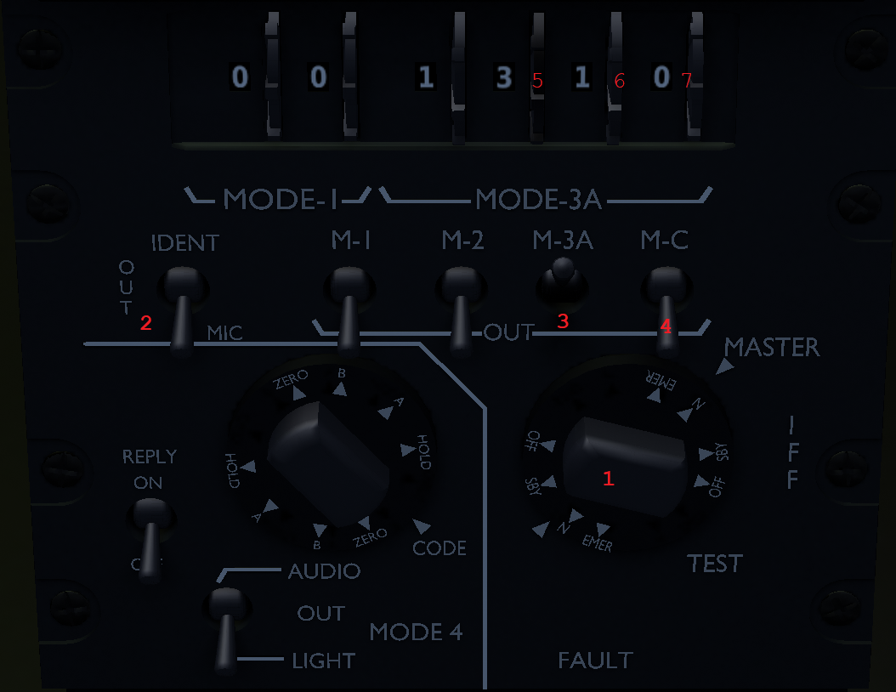
- Master transponder options
- Identification
- Identification
- Identification
- Set transponder frequency
- Set transponder frequency
- Set transponder frequency

Last words...

Some procedures in this manual have been adjusted to FlightGear standards, and to the current development state of the Mirage 2000 as of July 2020. If some major changes occur, a newer version of this manual will be released.
Free for use and for redistribution. For anything relevant with this manual, contact the author (Wolf) at renaud.roquefort@gmail.com , or via Discord, #8498.

I hope this manual helped you learning how to fly the Delta Knife and that I’ll see you in the skies with it in the near future!

-Wolf

Acknowledgements

I would like to thank everyone who helped me on this project.
My first words of thanks go to S. “VooDoo3” Liakos, who gave me the idea of the manual in the first place, and for being a great, supportive friend. I am not certain this manual would exist without him. I thank I. “Interce” Klimov, 5H1N0B1 and CUDA22 as well for their support during the creation of this manual. Thank you to all who did changes and improvements to this manual, or pointed out things to modify: Legoboyvdlp, Rudolf, CUDA22, Reaper, and 5H1N0B1 himself. I am also very indebted to all those who worked hard to create what the Mirage 2000-5 is as of today: 5H1N0B1, Onox, Hardba11, J-Mav16, F-Sig, J. "Octal450" Davidson, Leto, R. Harrisson, Legoboyvdlp, D. "Rudolf" Juttner, Ravenclaw_007 and so many others left unnamed but who also contributed to the aircraft. I appreciate everything each one of you did. I am sincerely grateful for all your help.

